FOOTSTEPS Part 2

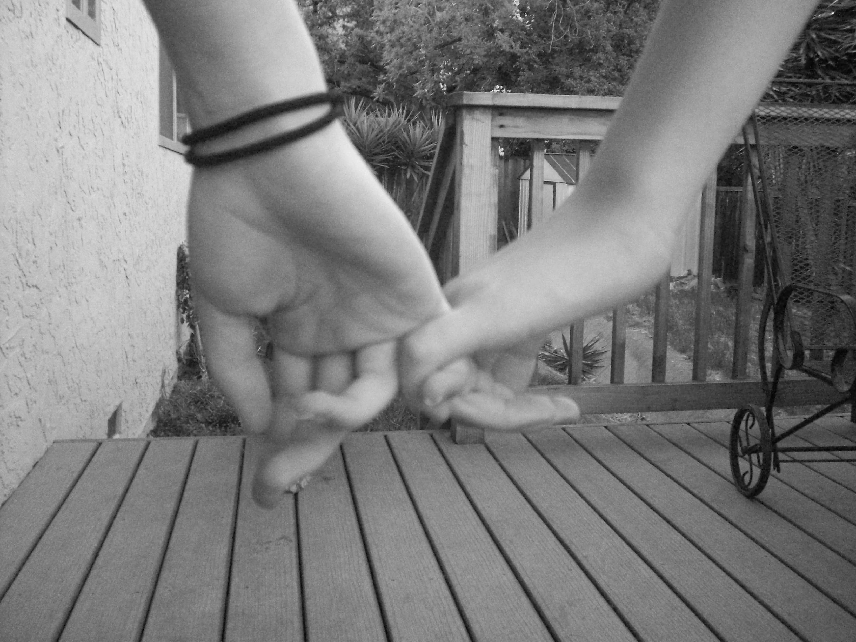
you start walking again
slowly
unsurely
taking hesitant steps
because
No One
wants to walk alone
but you keep going
Footsteps... an echo
running running, echoing
LOUD
down the hallway behind you
you turn and stop
and smile
it's a smile of relief
of love
of companionship
and your friend smiles the same smile
of love
of consolidarity
and
without a word
you link pinkies
and turn back to the now not so deserted hallway
and start walking again
But this time the footsteps are different
In unison, but the sound of two
vibrating across the floor
confident
careless
fearless
ready for whatever more

